 

A Minor Project Report On

#### IMAGE RECOGNITION WITH MACHINE LEARNING

Submitted in partial fulfilment of requirements for the reward of the Degree of

#### BACHELOR OF TECHNOLOGY

In

#### ARTIFICIAL INTELLIGENCE AND DATA SCIENCE

Under the guidance of

#### Mr. R. STALIN BABU

Assistant Professor/AI

#### Submitted by

DHINAGARAN V P (927621BAD010)

DINESH S (927621BAD011)

KAVIN K V (927621BAD021) SHARAN ADHITHYA S (927621BAD047) ROHITH U (927621BAD302)

DEPARTMENT OF

ARTIFICIAL INTELLIGENCE AND DATA SCIENCE M.KUMARASAMY COLLEGE OF ENGINEERING

(Autonomous)

KARUR – 639113

APRIL - 2023

VISION AND MISSION OF THE INSTITUTE:

#### Vision:

To emerge as a leader among the top institutions in the field of technical education.

#### Mission:

* Produce smart technocrats with empirical knowledge who can surmount the global challenges.
* Create a diverse, fully-engaged, learner-centric campus environment to provide quality education to the students.
* Maintain mutually beneficial partnerships with our alumni, industry and professional associations.

VISION AND MISSION OF THE DEPARTMENT:

#### VISION

To achieve education and research excellence in Artificial Intelligence.

#### MISSION

* To impart quality and value based education and contribute towards the innovation of computing, expert system, Data Science to raise satisfaction level of all stakeholders.
* To educate the future Computing engineers with strong fundamentals by continuously improving the teaching learning methodologies using contemporary aids.
* Enabling students to get expertise in critical skills with Artificial Intelligence domain and facilitate socially responsive research and innovation.
* To encourage professional development of students that will inculcate ethical values and leadership skills while working with the community to address societal issues.

#### PROGRAMME OUTCOMES (POs)

* **Engineering knowledge:** Apply the knowledge of mathematics, science, engineering fundamentals, and an engineering specialization to the solution of complex engineering problems.
* **Problem analysis:** Identify, formulate, review research literature, and analyze complex engineering problems reaching substantiated conclusions using first principles of mathematics, natural sciences, and engineering sciences.
* **Design/development of solutions:** Design solutions for complex engineering problems and design system components or processes that meet the specified needs with appropriate consideration for the public health and safety, and the cultural, societal, and environmental considerations.
* **Conduct investigations of complex problems:** Use research-based knowledge and research methods including design of experiments, analysis and interpretation of data, and synthesis of the information to provide valid conclusions.
* **Modern tool usage:** Create, select, and apply appropriate techniques, resources, and modern engineering and IT tools including prediction and modeling to complex engineering activities with an understanding of the limitations.
* **The engineer and society:** Apply reasoning informed by the contextual knowledge to assess societal, health, safety, legal and cultural issues and the consequent responsibilities relevant to the professional engineering practice.
* **Environment and sustainability:** Understand the impact of the professional engineering solutions in societal and environmental contexts, and demonstrate the knowledge of, and need for sustainable development.
* **Ethics:** Apply ethical principles and commit to professional ethics and responsibilities and norms of the engineering practice.
* **Individual and team work:** Function effectively as an individual, and as a member or leader in diverse teams, and in multidisciplinary settings.
* **Communication:** Communicate effectively on complex engineering activities with the engineering community and with society at large, such as, being able to

comprehend and write effective reports and design documentation, make effective presentations, and give and receive clear instructions.

* **Project management and finance:** Demonstrate knowledge and understanding of the engineering and management principles and apply these to one’s own work, as a member and leader in a team, to manage projects and in multidisciplinary environments.
* **Life-long learning:** Recognize the need for, and have the preparation and ability to engage in independent and life-long learning in the broadest context of technological change.

#### PROGRAM SPECIFIC OUTCOMES (PSOs)

* **Professional Skills:** Ability to apply the knowledge of computing techniques to design and develop computerized solutions for the problems.
* **Successful career:** Ability to utilize the computing skills and ethical values in creating a successful career.

#### MAPPING OF PROJECT WITH PO’S AND PSO’S:

* + Engineering knowledge
  + Problem analysis
  + Design/development of solutions
  + Modern tool usage
  + Environment and sustainability
  + Individual and team work
  + Life-long learning
  + **PSO’S:** Professional Skills

# M.KUMARASAMY COLLEGE OF ENGINEERING

**(Autonomous Institution affiliated to Anna University, Chennai)**

## BONAFIDE CERTIFICATE

Certified that this project report **“IMAGE RECOGNITION WITH MACHINE LEARNING”** is the Bonafide work of **“DHINAGARAN V P (927621BAD010), DINESH S (927621BAD011), KAVIN K V (927621BAD021), SHARAN ADHITHYA S (927621BAD047),**

**ROHITH U (927621BAD302)”** who carried out the minor project work during the academic year 2022-2023 under our supervision. Certified further, that to the best of our knowledge the work reported herein does not form part of any other minor project report or dissertation on the basis of which a degree or award was conferred on an earlier occasion on this or any other candidate.

Signature Signature

Mr. R. STALIN BABU Dr. N. M SARAVANA KUMAR

Assistant Professor/AI HEAD OF THE DEPARTMENT Department of Artificial Intelligence, Department of Artificial Intelligence, M, .Kumarasamy College of Engineering, M.Kumarasamy College of Engineering Thalavapalayam, Thalavapalayam,

Karur-639113. Karur-639113.

**TABLE OF CONTENTS**

|  |  |  |
| --- | --- | --- |
| **CHAPTER NO** | **TITLE** | **PAGE NO** |
|  | **ABSTRACT** | **7** |
|  | **LIST OF FIGURES** | **8** |
|  | **LIST OF TABLES** | **8** |
|  | **ACRONYMS/LIST OF ABBREVIATIONS** | **8** |
| **1** | **INTRODUCTION** | **9** |
|  | 1.1 BACKGROUND | **9** |
|  | 1.2 PROBLEM STATEMENT | **9** |
|  | 1.3 OBJECTIVES | **10** |
| **2** | **LITERATURE REVIEW** | **11** |
| **3** | **FEASIBILITY STUDY** | **12** |
| **4** | **PROJECT METHODOLOGY** | **13** |
|  | 4.1 DESCRIPTION OF WORKING FLOW OF PROPOSED SYSTEM. | **13** |
| **5** | **RESULTS AND DISCUSSION** | **14** |
| **6** | **CONCLUSION** | **17** |
| **7** | **REFERENCES** | **18** |

# ABSTRACT

### Image recognition is a field of computer vision that deals with the automated identification of objects, places, or people in digital images or videos. Machine learning is a type of artificial intelligence that allows computers to learn without being explicitly programmed. When combined, image recognition and machine learning can be used to create powerful systems that can identify objects in images with a high degree of accuracy. There are many different machine learning algorithms that can be used for image recognition. Some of the most common algorithms include support vector machines, decision trees, and neural networks. Once the algorithm has been trained, it can be used to identify objects in new images. This can be done by feeding the new images into the algorithm and then predicting the class of each object. The accuracy of the predictions will depend on the quality of the training data and the complexity of the algorithm.

#### LIST OF FIGURES:

|  |  |  |
| --- | --- | --- |
| **Figure No** | **Figure Name** | **Page No** |
| **1** | **Image Processing** | **18** |
| **2** | **Image identification** | **19** |
| **3** | **Output of Prediction** | **20** |

**LIST OF TABLES:**

|  |  |  |
| --- | --- | --- |
| **Table No** | **Table Name** | **Page No** |
| **1** | **Literature review** | **11** |
| **2** | **Feasibility study** | **12** |

**ACRONYMS/LIST OF ABBREVIATIONS:**

|  |  |
| --- | --- |
| **Acronym** | **Abbreviations** |
| **PYTHON** | **Python Programming Language** |
| **ML** | **Machine Learning** |

# CHAPTER-1 INTRODUCTION

Object Recognition is a technology that lies under the broader domain of Computer Vision. This technology is capable of identifying objects that exist in images and videos and tracking them. Object Recognition also known as Object Detection, has various applications like face recognition, vehicle recognition, pedestrian counting, self-driving vehicles, security systems, and a lot more.

#### BACKGROUND:

Image recognition with machine learning is a rapidly growing field with a wide range of potential applications. As the technology continues to develop, we can expect to see even more innovative and exciting applications of image recognition in the years to come. There are many different machine learning algorithms that can be used for image recognition. Some of the most common algorithms include support vector machines, decision trees, and neural networks. The choice of algorithm will depend on the specific task at hand.

#### PROBLEM STATEMENT:

This technology is also used in autonomous vehicles to detect obstacles and navigate roads. Object detection can be used to identify individuals objects in images. By combining image recognition and machine learning, computers are able to identify objects and other features in images with increasing accuracy. Additionally, the accuracy of the computer’s predictions can vary depending on the quality of the images.

#### OBJECTIVES:

Image recognition is a powerful tool that can be used to automate a wide range of tasks. However, it is important to note that image recognition is not perfect. Models can make mistakes, especially when the images are noisy or cluttered. It is important to use image recognition in conjunction with other methods, such as human verification, to ensure accuracy. Object detection is used to identify objects in images. It is used in a variety of applications, such as self-driving cars, robotics, and medical image analysis.

|  |  |  |  |  |  |
| --- | --- | --- | --- | --- | --- |
| **CHAPTER-2 LITERATURE REVIEW** | | | | | |
|  | **S. NO** | **LINK REFERRED** | **DESCRIPTION** | **INFERENCE** | **FUTURE WORKS** |
| **1.** | **http://www.i jeast.com** | **To know the basics of the languages used for this project.** | **Studied the present working system.** | **To create a model using the training dataset.** |
| **2** | **https://towar dsdatascience**  **.com** | **Gained basic knowledge about the project** | **Studied about the existing system.** | **Changes have been made with respect to the existing systems** |
| 11 | | | | | |

# CHAPTER-3 FEASIBILITY STUDY

#### TRAINED & LABELLED DATA MODULE:

The page where the Trained or Labelled data are have to compare with the input to gain accuracy.

#### FEATURE EXTRACTION MODULE:

The method of reducing the input variable to your model by using only relevant data and getting rid of noise in data.

#### PATTERN IDENTIFICATION MODULE:

The page where data analysis method that uses machine learning algorithms to automatically recognize patterns and regularities in data.

#### OUTPUT MODULE:

The page where the Predicted output about problem statement display.

# CHAPTER-4 PROJECT METHODOLOGY

* 1. **DESCRIPTION OF THE WORKING FLOW OF PROPOSAL SYSTEM:**

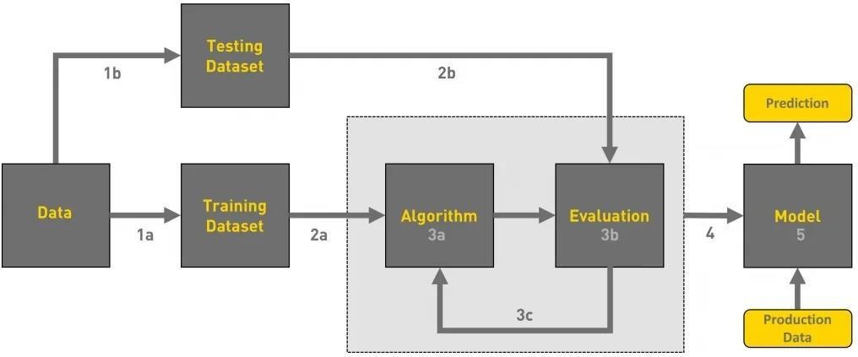

# CHAPTER-5 RESULTS AND DISCUSSION

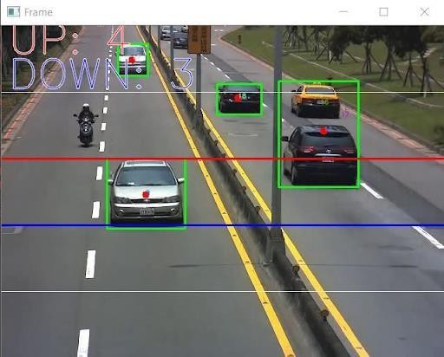

**Figure No 5.1 Image Processing**

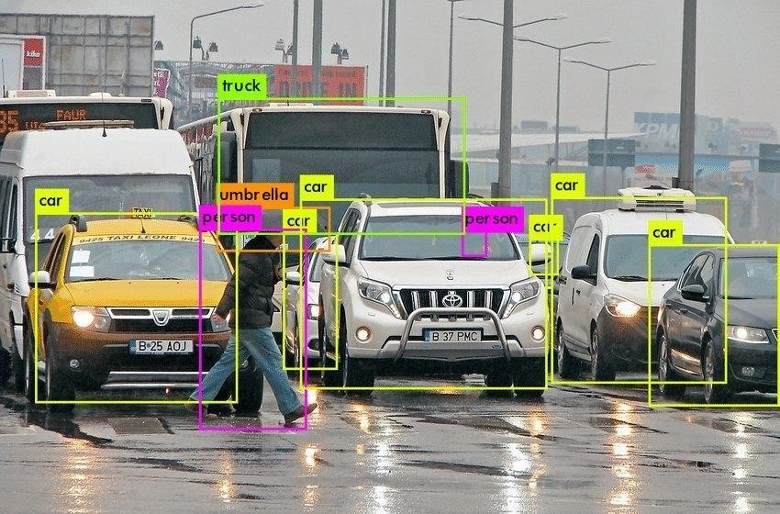

**Figure No 5.2 Pattern Identification**

## OUTPUT

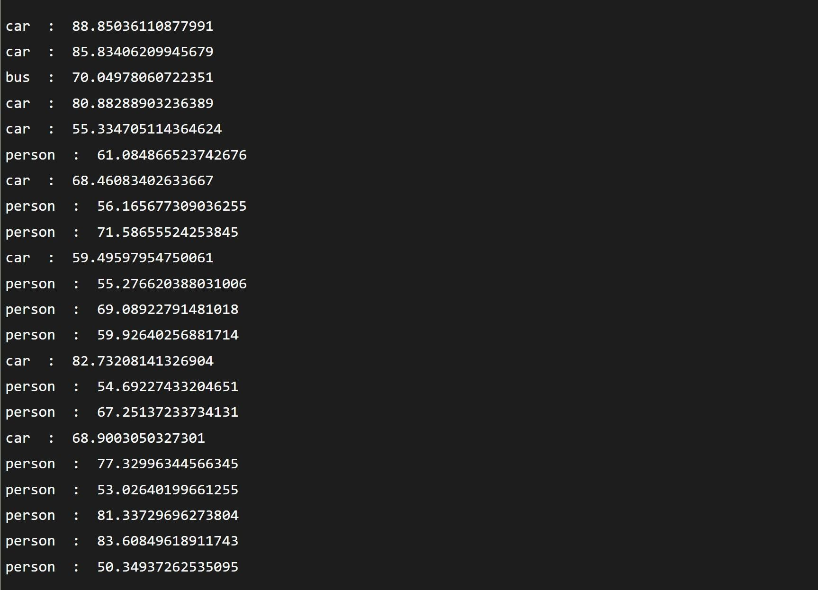

**Figure No 5.3 Output of prediction**

# CHAPTER-6 CONCLUSION

Autonomous vehicles will benefit the economy through fuel efficiency, the environment through reduced carbon emissions, society through more togetherness, and the legal system through a simpler system of liability. Object detection is a critical component of autonomous vehicles, as it enables the vehicle to perceive its environment and make informed decisions about how to navigate through it. With advances in machine learning, computer vision, and sensor technology, object detection algorithms have become more accurate and reliable, enabling autonomous vehicles to identify and track objects in real-time.

# CHAPTER -7 REFERENCE

###  Thomas, Elsken; Jan Hendrik, Metzen; Hutter (2017-11-13). "Simple and Efficient Architecture for Convolutional Neural Networks".

* + 1. Elsken, Thomas; Metzen, Jan Hendrik; Hutter, Frank (2018-04- 24)."Efficient Multi-objective Neural Architecture Search via Lamarckian Evolution".

### Springenberg, Jost Tobias; Dosovitskiy, Alexey , Thomas Riedmiller, Martin (2014-12-21)."Striving for Simplicity: The All- Convolutional Net".